# **Name: Abdurrahman Qureshi**

# **Roll.no: 210451**

**Practical No. 7:**

* **TRANSLATION**

**CODE:**

#include<stdio.h>

#include<conio.h>

#include<graphics.h>

#include<dos.h>

void main()

{

int gd=DETECT,gm;

int a[50],b[50],tx,ty,n,i;

initgraph(&gd,&gm,"C:\\TURBOC3\\BGI");

cleardevice();

printf("\n");

printf("Enter no. of vertices:\n");

scanf("%d",&n);

printf("Enter no of coordinates:\n");

for(i=0;i<n*2;i++)

{

scanf("%d%d",&a[i],&a[i+1]);

i++;

}

a[i]=a[0];

a[i+1]=a[1];

for(i=0;i<n*2;i++)

{

line(a[i],a[i+1],a[i+2],a[i+3]);

i++;

}

printf("Enter translation factors:");

scanf("%d%d",&tx,&ty);

for(i=0;i<n*2;i++)

{

b[i]=a[i]+tx;

b[i+1]=a[i+1]+ty;

i++;

}

b[i]=b[0];

b[i+1]=b[1];

printf("After translation:");

for(i=0;i<n*2;i++)

{

line(b[i],b[i+1],b[i+2],b[i+3]);

i++;

}

getch();

closegraph();

}

**OUTPUT:**

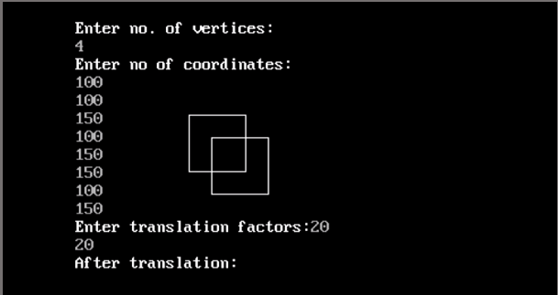

* **SCALING**

**CODE:**

#include<stdio.h>

#include<conio.h>

#include<graphics.h>

#include<dos.h>

void main()

{

int gd=DETECT,gm;

int a[50],b[50],sx,sy,n,i;

initgraph(&gd,&gm,"C:\\TURBOC3\\BGI");

cleardevice();

printf("\n");

printf("Enter no. of vertices:\n");

scanf("%d",&n);

printf("Enter no of coordinates:\n");

for(i=0;i<n*2;i++)

{

scanf("%d%d",&a[i],&a[i+1]);

i++;

}

a[i]=a[0];

a[i+1]=a[1];

for(i=0;i<n*2;i++)

{

line(a[i],a[i+1],a[i+2],a[i+3]);

i++;

}

printf("Enter scaling factors:");

scanf("%d%d",&sx,&sy);

for(i=0;i<n*2;i++)

{

b[i]=a[i]*sx;

b[i+1]=a[i+1]*sy;

i++;

}

b[i]=b[0];

b[i+1]=b[1];

printf("After scaling:");

for(i=0;i<n*2;i++)

{

line(b[i],b[i+1],b[i+2],b[i+3]);

i++;

}

getch();

closegraph();

}

**OUTPUT:**

